SHREYA PANCHAL

1.Sign up for a free AWS or Azure account and log in to the Management Console. Take a screenshot of your dashboard showing your name or email in the top bar.
Answer: Sign up for a Free AWS Account and Login
Steps:
- Open your browser.
- Go to AWS Free Tier.
- Click Create a Free Account.
- Enter your email, password, and AWS account name.
- Verify your email and phone number.
- Add your payment details (AWS may verify your card).
- Choose the Basic Support Plan.
- Sign in to the AWS Management Console.
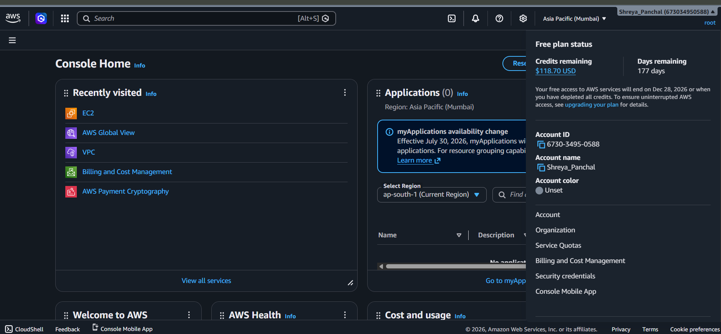

2.In the AWS or Azure Management Console, locate and list 5 key services (such as Compute, Storage, Database, Networking, Analytics). For each, write one line describing what it does and name one real app (like Instagram, Zomato, Flipkart) that could use it.
Answer: List 5 Key AWS Services
Service | Purpose | Example App
EC2 (Compute) | Runs virtual servers in the cloud. | Instagram hosts web servers on compute instances.
S3 (Storage) | Stores files, images, videos, and backups. | Spotify stores music files.
RDS (Database) | Provides managed relational databases. | Flipkart stores customer and product data.
VPC (Networking) | Creates secure private networks for cloud resources. | Paytm securely connects application servers.
CloudWatch (Monitoring) | Monitors applications, servers, and logs. | Zomato monitors server performance and errors.

3.Use the search bar in your AWS or Azure Console to find the S3 (AWS) or Blob Storage (Azure) service. Write down the steps you took to locate it and describe in 2-3 lines how a music app like Spotify could use this service to store user-uploaded files.
Answer: Locate Amazon S3
Steps:
- Login to the AWS Management Console.
- Click the Search bar at the top.
- Type S3.
- Select Amazon S3 from the search results.
- The Amazon S3 Dashboard opens.
How Spotify Uses Amazon S3:
Spotify can use Amazon S3 to store music files, album artwork, and user-uploaded content. S3 provides secure, reliable, and scalable storage so users can stream songs anytime without worrying about storage limitations.
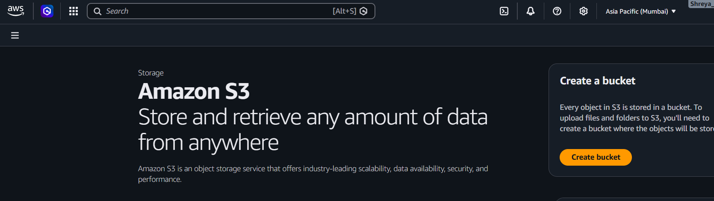

4.Pick one key characteristic of cloud computing (on-demand self-service, broad network access, resource pooling, rapid elasticity, or measured service) and explain, in your own words, how it benefits users of a popular app you use daily (e.g., Paytm, BookMyShow, IRCTC).<br><br><em><strong>Hint:</strong> Think about how these apps handle sudden spikes in users or data.</em>
Answer: Characteristic: Rapid Elasticity
Rapid elasticity means cloud resources can automatically increase or decrease based on demand.
Example (Book My Show):
When a new movie or cricket match ticket booking opens, millions of users visit BookMyShow at the same time. The cloud automatically adds more servers to handle the increased traffic, ensuring the website remains fast and available. After the traffic decreases, the extra servers are removed, which helps reduce costs.
Benefit:
- Handles sudden traffic spikes.
- Prevents website crashes.
- Improves user experience.
- Saves money by using resources only when needed.

